The Hardships and Pleasures of Academic Writing
A workshop on communicating scientific knowledge

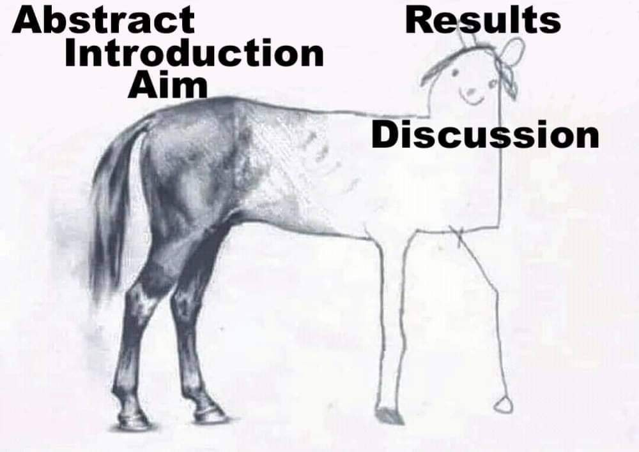

in academic writing

Speaker: Dr. Wolfgang Schmidt
IPMB, Academia Sinica, Taipei
11:00 Friday, July 14th, Auditorium Biblioteca Rizzi

